**Effective Partnering Strategies for Small Utilities**

*Katie Parkinson, Apex Analytics, Boulder, CO*

*Scott Dimetrosky, Apex Analytics, Boulder, CO*

*Kevin Kerrigan, Atmos Energy, Greeley, CO*

*Jeffrey Black, Colorado Natural Gas, Littleton, CO*

*Angela Twogood (Bowling), SourceGas, Golden, CO*

**ABSTRACT**

While a great deal of emphasis is placed on large utilities and the partnering of these large entities, relatively little attention is paid to small utilities and their unique needs. Small utilities face a unique set of challenges in designing and implementing a demand-side management program. In order to overcome these issues and achieve a cost-effective program, small utilities need to come up with new and innovative solutions. One such approach is to strategically partner with other small utilities within the region. This paper will address the benefits and challenges of operating a program as part of a partnership, using three Colorado utilities (Atmos Energy, SourceGas, and Colorado Natural Gas) as a case study.

Benefits associated with this collaboration include:

• Economies-of-scale with respect to program marketing, administration, delivery, tracking, and bulk purchases of program materials;

• Integrated marketing, efficiency measures, and rebate structures supporting a consistent message and minimizing confusion among Colorado customers;

• Integrated, consistent training on program protocols, guidelines, and installation best practices; and

• Development of a unique working partnership and cost savings benefits that have allowed the Partners in Energy Savings (PIES) group to provide substantial rebates incentivizing the installation of energy efficiency measures.

The ultimate desired result of this partnership is greater program participation, subsequent program savings, and increased cost-effectiveness for each utility involved, compared to what otherwise could be achieved with each acting independently.

**Introduction**

Three Colorado natural gas utilities, Atmos Energy Corporation, Colorado Natural Gas, and SourceGas Distribution, fund a portfolio of energy efficiency programs through the Partners in Energy Savings (PIES) Program, otherwise known as the Collaborative. This collaboration was approved by the Public Utilities Commission (PUC) of the State of Colorado on March 7, 2008.



The cost savings associated with using a collaborative approach allows each utility to direct more of its Demand Side Management (DSM) program dollars toward maximizing the installation of energy efficiency measures in its respective service territory. Additionally, designing collaborative programs with integrated marketing activities, efficiency measures and rebate structures permit lessen potential for confusion among natural gas consumers in the utilities' service. Although these programs are delivered and administrated collaboratively; however each utility partner tracks, documents, and reports program impacts, budgets, costs and other metrics separately. This structure allows for each utility to maintain their individual tracking and budgeting systems, rather than requiring all to adopt the same databases or reporting structures.

Development of this unique working partnership resulted in cost savings benefits and have allowed the collaborating utilities to set among the highest rebate levels in the state, establish a good living wage for its service providers, and direct more of its DSM program dollars toward the installation of energy efficiency measures, rather than to administration and overhead costs.[1]

The goal of this paper is to discuss one example of how utilities can overcome high administrative costs of DSM programs through collaboration, and the advantages and challenges associated with such a partnership.

**Utility Characteristics**

Atmos Energy Corporation, Colorado Natural Gas, and SourceGas Distribution are non-contiguous natural gas utilities located throughout Colorado (Figure 1). Cumulatively, they represent 224,000 customers throughout Colorado. Atmos is by far the largest of the three utilities, representing 112,000 active gas customers and a $606,000 2014 DSM budget. The second largest utility of the Collaborative is SourceGas, representing $92,000 customers, followed by Colorado Natural Gas with 20,000 customers.[2]

Figure : Energy Service Territories for Colorado Gas Collaborative Utilities

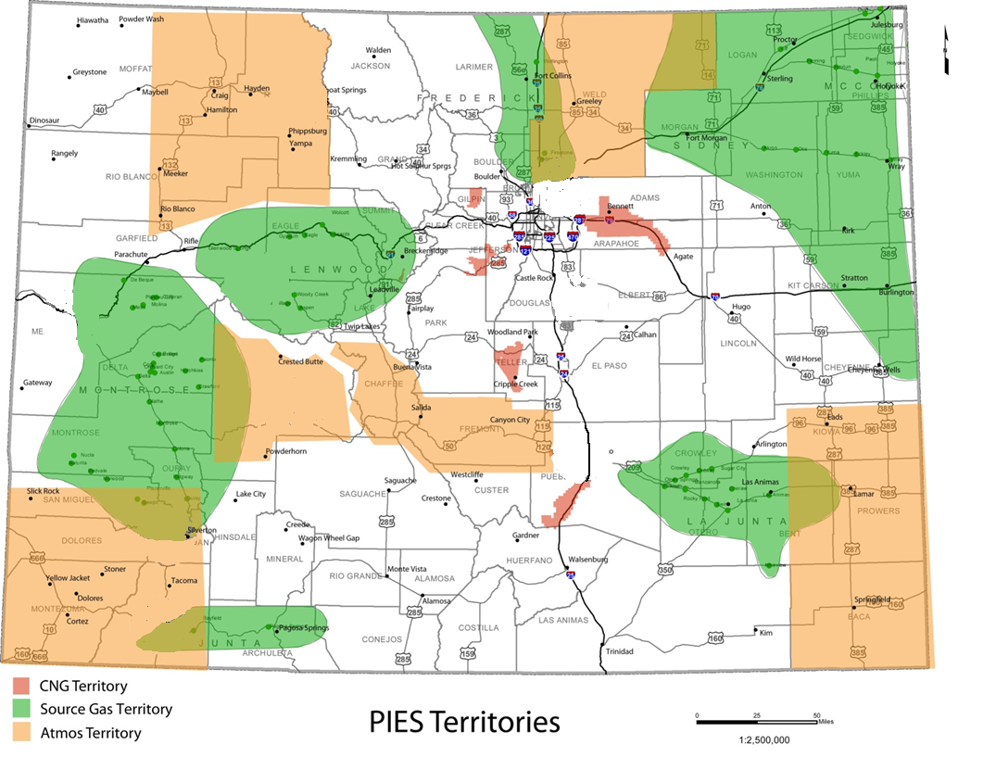

**Program Characteristics**

As required by Commission Rules, energy efficiency program budgets must represent over 2% of base rate revenues (exclusive of commodity costs) and 0.5% of its total revenues. Atmos Energy Corporation, Colorado Natural Gas, and SourceGas Distribution chose to partner together to implement the cost-effective energy efficiency programs required by these Colorado Public Utilities commission rules. The utilities did not implement DSM programs prior to forming this partnership. The Collaborative jointly funds and implements the following five natural gas efficiency programs:

* Energy Audit Program. An audit and report card of inefficient areas in the participant home, as well as the installation of free and low-cost energy efficiency measures;
* Efficient Natural Gas Rebate Program. Prescriptive rebate program for residential and small commercial customers;
* Income Qualified Program. Offers a variety of direct-install low-cost and high cost measures to qualified residences;
* Energy-Efficiency Kit Program. Offers a free kit of low cost efficiency measures for those who request it and for local area school children; and
* Custom Energy-Efficiency Program. Offers customized energy efficiency measures not included in the prescriptive programs for commercial and industrial customers.

Together, the programs offer 18 different energy efficiency measures. The variety of offerings allow the utilities to reach a variety of customers, from small and medium size commercial customers through the Custom Program, to small residential customers via the Income Qualified Program. The incentive levels remain the same for all utilities to allow consistency across territories and were determined during a jointly funded planning process, executed by a third party contractor. As with other pieces of the program implementation, the utilities have to decide collaboratively what measures and rebate levels work for all involved parties. Utilities have tailored their program offerings to fit their budgets and needs. For example, the smallest utility, Colorado Natural Gas, does not offer all the measures that the others have adopted. Table 1 provides an overview of programs and measures offered by the Collaborative.[3]

|  |  |  |  |  |  |
| --- | --- | --- | --- | --- | --- |
| **Measure** | **Efficient Natural Gas Rebate Program (Sector)** | | **Residential Energy Audit Program** | **Income Qualified Program** | **Energy-Efficiency  Kits[4]** |
| **Residential** | **Non-Residential** |
| Air Sealing | ✓ | ✓ |  | ✓ |  |
| Attic Insulation | ✓ | ✓ |  | ✓ |  |
| Boiler | ✓ | ✓ |  | ✓ |  |
| Caulk and Weather Stripping | ✓ | ✓ |  | ✓ |  |
| Crawlspace Insulation | ✓ | ✓ |  | ✓ |  |
| Faucet Aerator | ✓ | ✓ | ✓ | ✓ | ✓ |
| Floor Insulation | ✓ | ✓ |  | ✓ |  |
| Furnace | ✓ | ✓ |  | ✓ |  |
| Furnace Maintenance | ✓ | ✓ |  |  |  |
| Low-Flow Showerhead | ✓ | ✓ | ✓ | ✓ | ✓ |
| Low-Flow Sprayer |  | ✓ |  |  |  |
| Pipe Insulation |  |  | ✓ | ✓ |  |
| Programmable Thermostat | ✓ | ✓ | ✓ | ✓ |  |
| Proper Sizing (Furnace/Boiler) | ✓ | ✓ |  | ✓ |  |
| Wall Insulation | ✓ | ✓ |  | ✓ |  |
| Water Heater | ✓ | ✓ |  | ✓ |  |
| Water Heater Blanket | ✓ | ✓ | ✓ | ✓ |  |

Table : Overview of Programs and Measures

The Collaborative executes a robust marketing approach through a third party marketing firm responsible for the groups’ programs advertising. .. This approach relies primarily on traditional marketing channels to promote the efficiency programs, including print media, direct mail, Internet presence, and newspaper and radio advertisements. The Collaborative uses customer touch points such as service calls, newsletters, on-bill messaging, billboards, and speaking engagements at seminars, conferences, and community events to spread awareness about its programs. Some marketing materials, such as the Excess is Out website, are branded with the all the utilities’ brand and provides details for all the utilities programs. Other marketing, such as newsletters, will be nearly identical in wording, pictures, and layout, but will be branded by each utility individually to send to the individual utility customer. In either case, the members of the collaborative must agree on the marketing materials proposed by marketing firm, as they will be used for all members. Each member of the collaborative contributes to the advertising funds.

Additionally, the collaborative hires their third party program administrators as a group, not individually. These administrators report to each of the utilities and maintain individual goals for each. The administrator can then follow up on all marketing leads, rather than referring them to the individual utility for implementation.

**Successes and Challenges of Collaboration**

As mentioned earlier, jointly implementing DSM programs offers a number of benefits to the individual utilities and to the communities served. While the advantages to collaboration far outweigh the disadvantages, there are some challenges to executing programs in this particular manner. This section discusses both the benefits and drawbacks of collaboration, and lessons learned during the six years of the partnership.

**Strengths and Benefits of Collaboration**

The primary benefits to joint implementation of DSM programs are:

* Sharing of program costs and administration,
* Providing consistent program offerings,
* Economies of scale, and
* Knowledge sharing.

Each of these benefits is described in more detail in the following sections.

**Sharing of Program Costs**

Implementing DSM programs, especially publically regulated DSM programs, has a certain amount of fixed costs associated with them. For larger utilities, these costs are more easily absorbed and spread across programs and measures. However, these costs can prove prohibitive for small utilities, such as Colorado Natural Gas, with annual targets of only 750 participants. The collaborative has successfully shared the costs of DSM plans, annual reports, process and impact evaluations, marketing activities, and a potential study.

Similarly, there is a significant administrative burden associated with running DSM programs. For example, each of the Collaborative has only one staff member dedicated to demand side management, some of whom are not fully allocated to theses tasks. With these limited resources, it would be impossible to implement the five distinct programs the Collaborative has offered. The collaborative has successfully split some of the administrative tasks across the three utilities, such as:

* Request For Proposal (RFP) and proposal review process,
* Managing program implementers,
* Creating program protocols,
* Sharing customer documents and applications, and
* Website administration.

From an evaluation perspective, it costs less to evaluate or plan for the same program in three jurisdictions, even though the utilities each require their own report. Upfront program research, survey creation, database reviews, data analysis, meetings, and proposal time are all minimized when the Collaborative is considered one client, rather than three. Activities that are only slightly minimized, if at all, are reporting and commenting activities. Each utility in the Collaborative still needs their individual report, albeit in similar format, and have their own ideas on editing, formats, and comments. Additionally, each of the utilities have different contracting and invoicing requirements. The time spent on those tasks is not decreased by this collaborative effort.

**Consistency in Program Offerings**

This collaboration has also added value to the utility customers. As the programs have the same measures, efficiency levels, and rebates amounts, the utilities can provide consistent messaging and branding all over the state. Additionally, coordinating offerings minimizes confusion among Colorado customers as rebate offerings to not vary across territory lines. This also minimizes administrative time for participant contractors and installers as they are being trained on more limited programs and have the same rebate applications for all three areas.

**Economies of Scale**

Another benefit of utility collaboration is an increase in “buying power” with vendors and outside entities. Because they have joined together to implement the same programs, the Collaborative has qualified for quantity discounts on promotional materials, vendor services, and products (such as energy efficiency kits and faucet aerators) that they would not qualify for individually. Additionally, vendors such as marketing firms, rebate processors, and evaluators are more willing to bid on and partner with the Collaborative as they have significantly higher budgets as a group than as individual utilities.

**Knowledge Sharing**

The final strength of this Collaboration is the benefits associated with sharing knowledge among the partners. While this benefit is not something that can be directly quantified or measured, the advantage of learning from others’ experiencing should not be overlooked, especially in the early years of a program. These partners come together and share everything from implementation headaches to customer complaints, and work cohesively to find solutions. As each partner shares their experiences and strategies with the group, the learning curve to implementing these programs has been minimized for the individuals and considerable issues have been avoided.

**Challenges of Collaboration**

As with any project or program, this Collaboration has also had to overcome a few hurdles. The primary challenges these partners have experienced associated with group implementation are related to the varying needs among utilities and differences in consumer profiles.

**Varying Needs Among Utilities**

Both large and small utilities are accustomed to managing competing needs within their organization; evaluators want every characteristic of a home documented, while implementers want to minimize time in the home; contractors want to rebate every product they carry, while program managers look at the paperwork involved for additional measure. However, these differing needs can be multiplied when the group must work cohesively both *within* each organization and *between* the group. While the individuals associated with the Collaborative are experts at working together, there are inevitably times when needs of the individual utilities conflict with each other. The success of this kind of collaboration hinges on the ability of the program managers to get along and compromise. The utilities in the Collaborative have worked to overcome this by maintaining continuous communication through regular meetings, phone calls, and emails to help keep the utilities on the same page and work through any program issues as they arise.

**Differences in Consumer Profiles**

As mentioned earlier, utilities in the Collaborative have very different service territories, both in terms of the size of the territory and customer profile. Additionally, their service territories are not contiguous, meaning that there are customers spread throughout Colorado. The needs of the farmers in Greeley are not necessarily the same as the needs of those in the resort towns of the high country. The solution for this is to provide a wide range of program options. While this may be slightly more expensive than having a single, tailored program, it resulted in comprehensive program options to appeal to the variety of customers represented by the utilities.

**Conclusion**

In small utilities where the fixed costs to are a barrier to cost-effective DSM programs, partnering together can help lessen the financial and administrative burdens of implementation. Three natural gas utilities in Colorado have successfully collaborated in this manner and have chosen to continue this partnership for the foreseeable future.[5] And while these utilities have not yet met their targeted program participation and savings goals, benefits of this Collaboration have included

* **Economies of scale** associated with program marketing, administration, delivery, tracking, and bulk purchases of program materials;
* **Sharing of program costs and administration**, spreading tasks and costs throughout the partners reduces the cost of the executing programs;
* **Consistent program offerings,** efficiency measures and rebate structures supporting a consistent message and less confusion among Colorado customers; and
* **Knowledge sharing** among the partners helps avoid countless pitfalls experienced along the way.

However, the success of this collaborative effort is contingent upon the ability of the partner utilities to compromise and manage the needs of (sometimes) competing priorities. Similarly, these partnerships will be more easily executed if the territories share comparable geographies and customer demographics.

1. Colorado Natural Gas 2009 Annual DSM Report, Page 1.
2. Lessons Learned from the PIES Experience Presentation by Jeff Black, Rocky Mountain Utility Efficiency Exchange, September, 2014.
3. Atmos Energy Natural Gas Demand-Side Management Plan, 2012 Annual Report. April 1, 2013.
4. The Energy Efficiency Kits include 2 showerheads, 1 kitchen aerator, 2 faucet aerators, 1 roll of plumbers tape, and 1 hot water temperature card.
5. The utilities did not implement DSM programs prior to forming this partnership, therefore, a comparison between individual program implementation and collaborative implementation strategies could not be made.