Midterm Results from EISA 2007

Scott Dimetrosky and Katie Parkinson, Apex Analytics

# ABSTRACT

The 2007 Energy Independence and Security Act (EISA) enacted a number of substantial energy efficiency codes and standards, perhaps the most notable of which was the requirement that that most screw-based light bulbs become approximately 28% more energy efficient—as measured by the lumens per watt (LPW)—beginning in 2012. The legislation is phased-in, beginning with 100-watt equivalents in 2012, 75-watt equivalents in 2013, and 60/40-watt equivalents in 2014.

This paper provides an update on the phase-in, looking at EISA impacts through early 2014. Longitudinal results are presented, allowing for comparisons of findings with prior research from the following perspectives.

Supplier Perspective. Are lighting suppliers supporting the legislation? What actions have retailers and manufacturers taken to educate consumers, and what products are they stocking and promoting? Are lighting suppliers aware of this legislation?

Lamp Availability.What types of bulbs are available for retail sale? How has this changed since the beginning of EISA standards?

Consumer Perspective. Are consumers aware of the legislation? How have they responded? Have consumers stockpiled legacy incandescent bulbs? Are consumers “downsizing” to a lower wattage incandescent? Are they purchasing EISA compliant bulbs, or switching to CFLs? The paper will present data from a 10 states, relying on primary data collected as part of evaluation efforts throughout the U.S. The results are critical for understanding what savings are really being achieved by EISA, and what additional energy efficiency opportunities remain for program administrators.

# Background

In December of 2007, President George W. Bush signed the Energy Independence and Security Act (EISA). The law established energy management goals and requirements while also amending portions of the National Energy Conservation Policy Act (NECPA). The law includes a number of energy efficiency requirements, including federal energy use, motor standards, and a number of lighting requirements.

Perhaps the most notable EISA requirement is Section 321, which sets, for the first time, efficiency standards for “general service” light bulbs. Beginning in 2012, EISA requires that most screw-based light bulbs are approximately 28% more energy efficient—as measured by the lumens per watt (LPW). The law is technology neutral, stating “The regulation is not a product ‘ban’, but a performance requirement for wattage, lumen output and life.”[1] In other words, EISA requires typical light bulbs to be more efficient either by improving today’s typical light bulb or by the creation of new lighting products.

EISA legislation is implemented in stages, beginning with 100-watt equivalents in 2012, 75-watt equivalents in 2013, and 60/40-watt equivalents in 2014 (Table 1). Similar California legislation, Assembly Bill (AB) 1109, phased in these standards one year earlier than EISA requires. The law only regulates manufacturing, store retailers may sell legacy incandescent bulbs until they deplete their stock. A number of bulb exemptions are included in the bill, such as certain globe, candelabra, high lumen output bulbs.

Table 1. EISA and AB1109 General Service Lamp Requirements

|  |  |  |  |  |
| --- | --- | --- | --- | --- |
| Original Wattage | Rated Lumen Ranges | Maximum Rated Wattage | EISA Effective Date (Manufactured On or After) | AB 1109 Effective Date (Manufactured On or After) |
| 100 | 1490 – 2600  (High Brightness) | 72 | January 1, 2012 | January 1, 2011 |
| 75 | 1050 – 1489  (Medium-High Brightness) | 53 | January 1, 2013 | January 1, 2012 |
| 60 | 750 – 1049  (Medium-Low Brightness) | 43 | January 1, 2014 | January 1, 2013 |
| 40 | 310 – 749  (Low Brightness) | 29 | January 1, 2014 | January 1, 2013 |

*EISA 2007; AB 1109 2007*

# Study Methodology

This paper examined recent EISA studies from around the United States and compared them to similar, earlier studies conducted between 2010 and 2012. We pay particular attention to California results, as the requirements were enacted one year earlier, and thus – although the borders are porous – may provide a “preview” of how the standards could impact other areas of the country.

The analysis included a total of 14 studies, seven studies conducted between 2010 and 2011, and seven recent studies, conducted between 2012 and 2013. The consolidation of these studies allows for an in depth look of expectations and activities prior to and throughout the EISA phase in periods. This data shares perspectives of national manufacturers, corporate retailers, retail store managers, and consumers on the impacts of EISA legislation (Table 2). Additionally, shelf stocking studies illuminate changes in light bulb availability during this time.

Table 2. Data Sources and Activities Included in Current Study

|  |  |  |  |  |  |
| --- | --- | --- | --- | --- | --- |
| Primary Study Sponsor & State | Year Conducted | Manufacturer Interviews | Retailer/ Distributor Interviews | Consumer Surveys | Other Relevant Activities |
| Massachusetts Consortium | 2010 | 11 | 190 | 503 | Shelf Stocking |
| Massachusetts Consortium | 2011-2013 | 13 | 240 | 1,796 | Shelf Stocking, Lighting Inventories |
| PacifiCorp Wyoming | 2011 | NA | 23 | 254 | NA |
| PacifiCorp Washington | 2011 | NA | 12 | 251 | NA |
| PacifiCorp Idaho | 2011 | NA | 7 | 249 | NA |
| PacifiCorp California | 2011 | NA | 7 | 250 | NA |
| Commonwealth Edison - ComEd (IL) | 2011 | NA | NA | 400 | NA |
| Northwest Energy Efficiency Alliance - NEEA  (OR, WA, MT, ID) | 2010 | NA | NA | 500 | NA |
| Duke Energy Progress - DEP (NC, SC) | 2013 | 6 | 36 | 613 | Shelf Stocking |
| Northwest Energy Efficiency Alliance - NEEA (OR, WA, MT, ID) | 2013 | 12 | 5 | 776 | Shelf Stocking |
| California Public Utilities Commission - CPUC | 2011-2012 | 12 | 23 | 800 | Shelf Stocking |
| Connecticut Consortium | 2012 | NA | NA | 551 | Focus Groups |
| Commonwealth Edison - ComEd (IL) | 2013 | NA | NA | 792 | Shelf Stocking |
| New York State Energy Research and Development Authority – NYSERDA | 2012-2013 | NA | NA | 720 | Onsite Inventory |
| Total |  | 41 | 303 | 7,859 | NA |

*The Cadmus Group, Inc 2011; The Cadmus Group, Inc 2012; DNV Kema 2013; Navigant Consulting and Apex Analytics 2013; Navigant Consulting and Itron, Inc 2011; Navigant Consulting and Itron, Inc 2013; Kema 2010; NMR Group, Inc 2011; NMR Group, Inc 2012; NMR Group, Inc 2013.*

# Supplier Perspectives

Due to the upstream nature of the EISA legislation, light bulb suppliers have been some of the first to be affected by the EISA legislation. Any that previously manufactured 100 or 75 watt bulbs had to stop production of these bulbs and potentially switch to another technology. Their predictions on consumer preferences influence the manufacturing product mix and therefore, the future availability of retail lighting products. This section investigates EISA viewpoints and expectations from the National Electrical Manufacturers Association (NEMA), lighting manufacturers, corporate retailers, and retail store managers.

## National Electrical Manufacturers Association (NEMA)

One of the most vocal proponents of the EISA legislation was the National Electrical Manufacturers Association (NEMA), a trade association that includes many of the major lighting manufacturers. NEMA representatives testified multiple times before the House and Senate in support of the bill.[2] The motivation of the lighting manufacturers may have been environmental as well as economic, as the lighting market at the time was relatively “stale” having many low priced products that had not changed significantly in years. EISA provided a way to invigorate a market and create new economic opportunity for lighting manufacturers.

Lighting manufacturers, largely through NEMA, continued to demonstrate their support for EISA after it was signed into law. This support has been critical, particularly when EISA was at risk of getting repealed, and when the 2011 federal budget agreement included a rider that prohibited federal enforcement of all aspects of EISA. NEMA immediately issued a press release, stating, “NEMA […] remains committed to and supportive of the lighting standards established in the Energy Independence and Security Act of 2007. NEMA did not support the inclusion of this rider, which imposes funding limitations on the Department of Energy (DOE) to enforce the light bulb standards for FY2012 […] American manufacturers have invested millions of dollars in transitioning to energy efficient lighting as a result of the EISA 2007 provision. Delay in enforcement undermines those investments and creates regulatory uncertainty.” General Electric, as an example, has already closed down legacy incandescent manufacturing plans in Ohio, Kentucky, and Virginia and all major lighting manufacturers have introduced many new EISA compliant bulb types.

## EISA Awareness and Education Among Suppliers

Retailer awareness of EISA varies significantly between studies. A 2010 Massachusetts study found that only 48% of retail store managers were aware of EISA, compared to 92% of retail store managers in a 2011 PacifiCorp study, 67% in the 2012 Massachusetts study, and 80% in a 2013 Duke Energy Progress (DEP) Study. Among manufacturers, roughly one-third of supplier interview respondents in California were not aware of EISA shortly after it began phasing in during January, 2012. However, in the 2013 DEP evaluation, manufacturers were uniformly aware of EISA’s provisions, and all have already begun to make production changes in response. These variances may reflect some geographic differences, but likely reflect the difference over time as the EISA debate became more public and the initial requirements were implemented.

Less than a third (32%) of the 2011 lighting retailers planned to educate customers about the new requirements using marketing materials, such as in-store displays, point-of-sale materials, internet materials, guides for retail employees, and “educating retailers.”.[3] A 2012 DEP shelf stocking study of 70 retail stores found only one store, a large home improvement store, had any EISA signage. That store had one 7” x 16” sign in the lighting aisle explaining EISA requirements. In 2013, five of six manufacturers indicated that their company plans to educate customers or sales reps regarding EISA.

A few manufacturers of incandescent bulbs in a 2012 Massachusetts study indicated that they had seen a spike in sales of their incandescent products, which they attributed to hoarding. “We know that certain retailers stocked up based on the ruling,” said a representative for one of these manufacturers. Another manufacturer of incandescent bulbs gave a dramatic account of the hoarding of their higher-wattage products and predicted that similar reactions would occur as lower-wattage incandescent bulbs were phased out.

# Lamp Availability

Between 2009 and 2013, evaluators in California, North and South Carolina, Illinois, and the Northwest region (NEEA) conducted retailer shelf stocking studies, in part to assess the effect of EISA standards on light bulb stocking practices. Findings, below, are segmented by brightness levels to be consistent with EISA phase in requirements. The California, Oregon, and NEEA results are limited to medium screw based (MSB), a-lamp shaped bulbs, therefore excluding exempted bulbs from the analysis.

As noted above, California adopted the EISA regulations one year in advance of the rest of the United States. Therefore, beginning in 2011, retailers were expected to sell through their existing stock of 100 watt incandescent bulbs and not order additional bulbs. Recall that the phase-out for high brightness A-lamps started in California on January 1, 2011 and for medium high brightness A-lamps in California on January 1, 2012.

## High Brightness MSB Incandescent A-Lamps (1490-2600 lumens)

While high brightness incandescent A-lamp bulbs were still available over a year after EISA or AB1109 phase out, the prevalence of these bulbs appears to be decreasing over time. For example, about six months after the 100-watt EISA standard went into place (June/July of 2012), 79% of DEP retailers visited in North and South Carolina were still carrying high brightness incandescent bulbs; eight months after the standard went into place, approximately 82% of stores visited in Massachusetts were still carrying 100 watt bulbs[4]; andnearly 18-months after the 100-watt standard went into place, 100-watt incandescent bulbs were still on the shelves at only 50% of ComEd (IL) program retailers.

Consumer survey results are also finding high availability of legacy incandescent lamps, however, they seem to be decreasing. For example, 18% of California consumers surveyed by DNV KEMA indicated that they shopped for traditional 100 watt incandescent lamps in 2011 (after AB1109 had gone into effect) and 65% of those consumers were successful. Similarly, of those customers that looked for 100W incandescent bulbs in 2012, over half (57%) were successful in the North and South Carolina, and 36% were successful in New York. In Winter of 2011 in Massachussets, 77% of households shopping for 100-Watt incandescent bulbs were able to find them on store shelves; this number decreased to 63% in the Summer of 2012 and again to 49% in the Winter of 2013.

Researchers in both California and the Northwest studied the prevalence of EISA compliant bulbs at various times during 2009, 2011, and 2012. These studies provide unique insights as to how high incandescent a-lamp bulbs have adjusted to the new legislation. As shown in Figure 1, while only 5% of bulbs met the EISA standards in NEEA service territory prior to legislative phase in (2011), 67% of bulbs met the standards one year after (2012). The percentage of high brightness MSB incandescent A-lamps that met the standard in 2012 was highest in big box stores (90%), increasing from 5% of total lamps during 2011. Similarly, California big box stores carried only 6% of complaint bulbs prior to legislation (2009), and increased to 97% two years after (2012). The proportion of EISA-compliant high brightness general purpose A-lamps overall increased from just 36% of all high brightness general purpose A-lamps observed during Fall 2011 to 92% in Summer 2012. Home improvement stores experienced the largest change between Fall 2011 and Summer 2012, with the proportion of EISA-compliant high brightness general purpose A-lamps increasing from just 23% to 95% in less than a year.

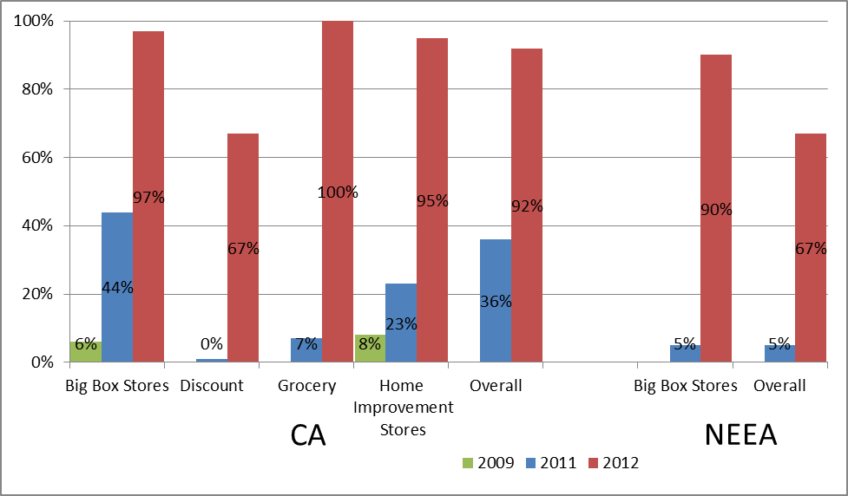

Figure 1. Percentage of High Brightness Bulbs Meeting EISA Standards. *Source:* DNV KEMA 2013; KEMA 2010.

## Medium High Brightness MSB Incandescent A-Lamps (1050-1489 lumens).

The standard for medium high brightness (1050—1489 lumens) MSB incandescent A-lamps went into effect on January 1, 2013 (2012, in California). Changes in these bulbs are similar to those in the high brightness category, but on a delayed trajectory. While data on this group is more limited, preliminary findings suggest these bulbs were also still available months after the initiation of the phase-in period. For example, six months after the 75-watt EISA standard went into place, 75-watt incandescent bulbs were still on the shelves at 100% of program retailers visited in the ComEd study.

Only 12 % of lamps in this category in Northwest retail stores met the relevant EISA standard at the time of the 2012 shelf surveys (up from 2% in 2011, Figure 2). This is slightly higher than the percentage of EISA-qualifying high brightness MSB incandescent A-lamps in stock in Northwest retail stores at the time of the 2011 shelf surveys (late 2011/early 2012), just as the standard for those lamps went into effect (5%).

In California, mass merchandise stores increased their stocking of EISA-compliant medium high brightness general purpose A-lamps from zero percent in Spring 2009 to 39% in Fall 2011 (Figure 2). By Summer 2012 (six months after AB1109 went into effect), the proportion of EISA-compliant lamps was up to 87% of all lamps in this lumen category. Across all stores in the California sample, EISA-compliant medium high brightness general purpose A-lamps represented 79% of medium high brightness A-lamps in Summer 2012 compared to just 18% in Fall 2011 and zero percent in Spring 2009. These results suggest that AB 1109 and/or EISA regulations have impacted the stocking patterns of medium high brightness general purpose A-lamps in California big box stores.

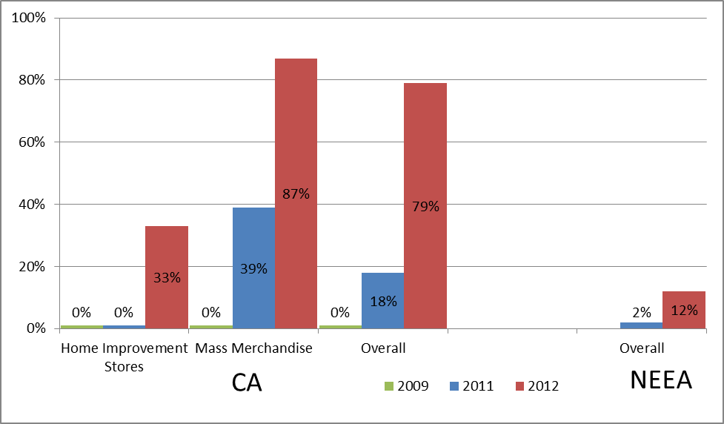

Figure 2. Percentage of Medium High Brightness Bulbs Meeting EISA Standards*. Source:* DNV KEMA 2013; KEMA 2010**.**

## Medium Low Brightness and Low Brightness MSB Incandescent A-Lamps.

At the time of this study, shelf stocking studies have not been released for bulbs phased out by EISA in 2014—medium low brightness (750-1049 lumens) and low brightness (310-749 lumens) bulbs. However, the recent NEEA reports that approximately 15 to 16 percent of all lamps stocked in Northwest retail stores in each lumen bin met the EISA standard in 2012, two years prior to EISA phase out. Additionally, the total number of medium low brightness MSB incandescent A-lamps stocked dropped substantially between years (from nearly 52,000 lamps in 2011 to less than 19,000 in 2012). This decrease may be indicative of an overall shift away from traditional incandescent technologies in Northwest retail stores as a result of EISA requirements.

## Percent of Lamp Types Stocked

The relative percentage of lamp types observed in retail stores is an indicator of the availability of different lamp types. These data are available for the Northwest region in 2011 and 2012, and for North and South Carolina for 2012. Based on these data, results suggest that:

* Although their share of total lamp stock declined overall between 2011 and 2012 (from 78% of all lamps stocked in the Northwest retail stores to 70%; 50% in the 2012 the Carolinas), incandescent lamps still dominated retail store inventories.
* CFLs grew to 28% of total northwest lamp stock in 2012 (up from 20% in 2011). CFLs represented 30% of 2012 lamp stock in the Carolinas.
* The distribution widely varied by retail channel. In Northwest big box stores, CFLs represented 32% of total lamp stock and in non- big box stores, 23%. In the Carolinas, warehouse stores stocked a far greater percent of CFLs (58%) than the average, while discount stores had a higher percent of incandescent packages (63%).

Similarly, in NEEA studies, the quantity of high brightness MSB incandescent A-lamps on retail shelves dropped by a factor of 10 between 2011 and 2012, suggesting a general phase-out of these types of lamps in Northwest retail stores.

# Consumer Perspective

## Consumer Awareness of EISA

As shown in Figure 3, consumer awareness of EISA varies significantly across the country, but in general awareness remained relatively low prior to the EISA phase-in. Among the PacifiCorp customer surveys, which were all conducted in fall 2011 and used identical language; awareness was highest in Wyoming (64%) and lowest in California (45%). The high awareness in Wyoming may reflect the politically conservative nature of the state, and the awareness of government regulations due to the influence of the extraction (oil and gas) industries. Interestingly, consumer awareness in the California service territory of PacifiCorp – although representing a small portion of the state – was not significantly different than a number of other service territories in states served by PacifiCorp, despite the earlier adoption of EISA in California.

Consumer awareness across the Northwest (23%), and in Massachusetts (25%) and ComEd (35%), were even lower. These may reflect the timing of the surveys, as the Northwest and Massachusetts studies were conducted in 2010 and the ComEd study in early 2011. In fact, Massachusetts reported a significant jump in EISA awareness in 2009 (only 18%) to 2010 (25%). New York experienced a similar jump in awareness from 33% in 2011 to 38% in 2012. The results of all these studies show that consumer awareness of EISA, even in 2012, remains relatively low.



Figure 3. Percent of Residential Customers Aware of EISA, 2009-2011[5]. *Source:* The Cadmus Group, Inc 2011; The Cadmus Group, Inc 2012; DNV Kema 2013; Navigant Consulting and Itron, Inc 2011; Kema 2010; NMR Group, Inc 2011.

More current studies show low awareness of EISA legislation. Approximately 28% of DEP respondents (2012), 37% in California (2012), 39% in Connecticut (2012), 46% in the Carolinas (2012), and 64% in Illinois (2013) were reported to be aware of forthcoming lighting legislation. The ComEd service territory had the highest awareness of EISA standards at 64% in 2013. This awareness is up from 53% in 2012 and 35% in 2011 (Figure 4).

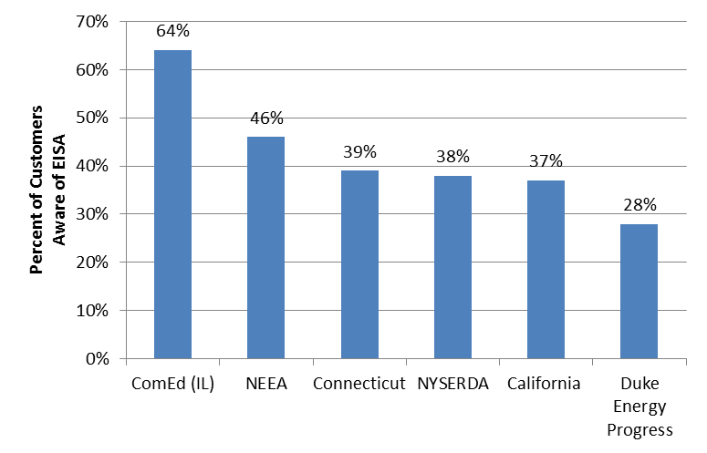

Figure 4. Percent of Residential Customers Aware of EISA, 2012-2013[6]. *Source:* DNV Kema 2013; Navigant Consulting and Apex Analytics 2013; Navigant Consulting and Itron, Inc 2013; NMR Group, Inc 2012; NMR Group, Inc 2013; NMR Group, Inc and Apex Analytics 2014.

## Consumer Responses to EISA

Some studies have found that consumers, when told about the legislation, report an intention to possibly stock pile incandescent bulbs. For example, in the 2011 ComEd study, consumers who were not aware of EISA were read a description of the legislation, read four descriptions of possible actions they would take for light sockets where they have used 100-watt incandescent, and finally asked the likelihood of each action. The most likely action chosen was the stockpiling of existing 100-watt incandescent bulbs, as 45% of respondents gave a rating from 7 to 10 (on a 10-point scale) when asked if they would purchase extra 100-watt incandescent bulbs before the law goes into effect. Similarly, six consumer focus groups held in Connecticut in late 2011 found a high propensity towards the stated intention of incandescent lamp hoarding, with 10 out of 23 participants indicating that they are currently hoarding or would consider hoarding incandescent lamps.

However, two studies found that considerably fewer consumers actually stockpiled 100w bulbs compared to the stated intentions. For example, only 8% of DEP respondents indicated that they had bought extra 100W bulbs to use after the law went into effect, and the 2013 NYSERDA study found negligible (less than 1%) of on-site inspection participants hoarded bulbs in 2012.

Generally, survey results indicate that consumers would choose a lower wattage incandescent or a CFL when 100 watt bulbs are eliminated (Figure 5). ComEd 2013 survey respondents reported an increased likelihood to purchase CFLs and a decreased likelihood to purchase halogen bulbs, with 51% reporting they will likely buy CFLs and only 7% reporting they will likely buy halogen bulbs. However, 39% of respondents in Connecticut chose a lower wattage incandescent and 34% chose a CFL when forced to choose a new bulb. Common reasons for choosing an incandescent bulb included preference for the light quality and familiarity with the product. Many respondents choosing CFLs noted their energy or bill savings.

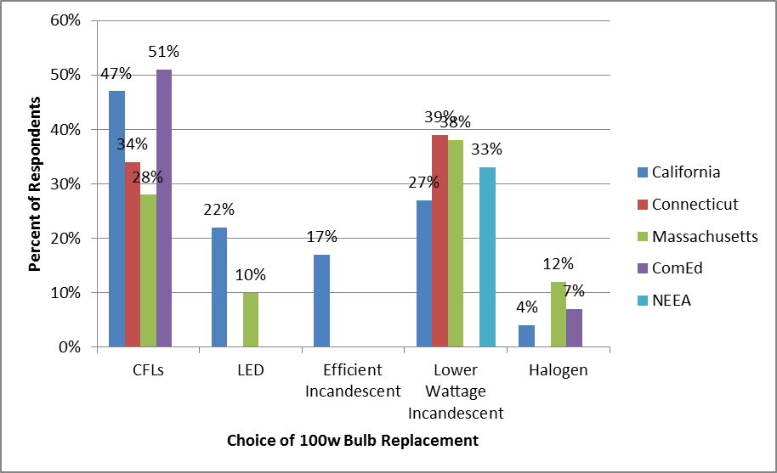

Figure 5. Replacement Bulb Technologies. *Source: DNV* Kema 2013; Navigant Consulting and Itron, Inc 2011; Navigant Consulting and Itron, Inc 2013; NMR Group, Inc 2012; NMR Group, Inc 2013.

When asked about customer reaction to EISA, 24% of the 2011 PacfiCorp lighting retailers and 46% of 2013 DEP lighting retailers said they had received negative feedback from customers. The feedback included frustration at the government telling them what to do, difficulty understanding technical details (e.g., lumens, lumens per watt), dissatisfaction with the number of incandescent options available, as well as dissatisfaction with CFLs’ lighting quality and mercury content. Five of the six 2013DEP manufacturers had received feedback on EISA from customers or retailers. Two indicated that customers needed clarification on the standard. One indicated that low-income consumers were angry about the higher price of complying alternatives. This increase in complaints over time is most likely due to a rise in consumer awareness of the legislation at the same time the requirements are becoming more stringent.

# Summary and Conclusions

This paper revealed several trends in the lighting market as a result of the EISA legislation, namely:

* + ***Lighting manufacturers are committed to EISA***. Lighting manufacturers supported the adoption of the EISA standards, and have stated their commitment to EISA even when the federal government has debated repealing the law and eliminated enforcement of the law. Five of six manufacturers indicated that their company plans to educate customers or sales reps regarding EISA.
  + ***There is a significant sell-through period for pre-EISA bulbs.*** At the midway point (June/July) of 2012, 79% of DEP retailers visited in North and South Carolina were still carrying high brightness incandescent bulbs; eight months after the standard went into place, approximately 82% of stores visited in Massachusetts were still carrying 100 watt bulbs[7]; and nearly 18-months after the 100-watt EISA standard went into place, 100-watt incandescent bulbs were still on the shelves at 50% of ComEd program retailers.
  + ***EISA and AB1109 have changed the landscape of high brightness bulbs.*** While only 5% of bulbs met these standards in NEEA service territory prior to legislative phase in (2011), 67% of bulbs met the standards one year after (2012). Similarly, California big box stores carried only 6% of complaint bulbs prior to legislation (2009), and increased to 97% two years after (2012).
  + ***Consumer awareness remains extremely low***. Studies conducted 2010 – 2013 in a number of areas in the U.S. have found that less than half of consumers are aware of EISA. Of the states polled, awareness was highest in Wyoming and Illinois.
  + ***Consumers stockpiled 100 watt bulbs less than anticipated.*** Only 8% of respondents in the Carolinas and 1% of respondents in New York indicated that they bought extra 100 watt bulbs in preparation for the new laws.

While EISA appears to be changing the market for lighting products, the change is happening slower than anticipated and with less resistance. Regulators and evaluators should consider this longer sell-through period in their baseline estimates. While EISA compliant bulbs may be more efficient that their pre-EISA equivalents, technologies such as LEDs, will offer superior energy savings. Programs should encourage customers toward more efficient lighting technologies to ensure consumers do not perceive EISA compliant bulbs as the most efficient lighting option.

# References

The Cadmus Group, Inc / Energy Services. Rocky Mountain Power Wyoming Residential Home Energy Savings Evaluation. October, 2011.

The Cadmus Group, Inc / Energy Services. Pacific Power Washington 2009-2010 Home Energy Savings Evaluation. 2012.

The Cadmus Group, Inc / Energy Services. Pacific Power California 2009-2010 Home Energy Savings Evaluation. 2012.

The Cadmus Group, Inc / Energy Services. Rocky Mountain Power Idaho 2009-2010 Home Energy Savings Evaluation. 2012.

The Cadmus Group, Inc and NMR Group, Inc. Residential Lighting Shelf Survey and Pricing Analysis (MA). June 8, 2013.

DNV Kema Energy & Sustainability. Assessment of the Early Effects of EISA and AB 1109 in California. 2013.

DNV Kema Energy & Sustainability. 2012-2013 Northwest Residential Lighting Market Tracking Study. 2013.

Navigant Consulting and Apex Analytics. EM&V Report for the 2012 Energy Efficient Lighting Program for Duke Energy Progress. 2013.

Navigant Consulting and Itron, Inc. Commonwealth Edison, PY3 Residential Utility ENERGY STAR Lighting Program Evaluation. 2011.

Navigant Consulting and Itron, Inc. Commonwealth Edison, PY5 Residential Utility ENERGY STAR Lighting Program Evaluation. 2013.

National Electrical Manufacturers Association. December 2011. NEMA Reiterates that Lightbulb Efficiency Standards Remain, Consumers Retain Diverse Options for Efficient Lightbulbs. <http://www.nema.org/media/pr/20111216a.cfm>

Kema. Northwest Energy Efficiency Alliance (NEEA), 2009-2010 Residential Lighting Market Research Study (Report #10-216). May 18, 2010.

NMR Group, Inc. Connecticut Efficient Lighting Saturation and Market Assessment. 2012.

NMR Group, Inc. Summary of Preliminary Findings from the Residential Lighting POS Program Evaluation Study. July 24, 2013.

NMR Group, Inc and Apex Analytics. Market Effects Market assessment, Process and Impact Evaluation of the NYSERDA Statewide Residential Point of Sale Lighting Program: 2010-2012. 2014.

NMR Group, Inc., Cadmus Group, Inc, KEMA. Massachusetts ENERGY STAR Lighting Program 2010 Annual Report, Volumes 1 & 2. June 15, 2011.

NMR Group, Inc., Cadmus Group, Inc, KEMA. Lighting Retailer, Supplier Perspectives on the Massachusetts ENERGY STAR Lighting Program (2011-2012). June 2013.

NMR Group, Inc. and DNV-KEMA. Massachusetts Energy Star Lighting Program: Early Impacts of EISA. June 2013.

1. The full text of EISA is available at http://www.gpo.gov/fdsys/pkg/BILLS-110hr6enr/pdf/BILLS-110hr6enr.pdf
2. See <http://www.nema.org/gov/energy/positions/> for NEMA press releases regarding their support of EISA.
3. Note, however, there are some national retailers, such as Ikea and Target, that have publically stated they are phasing out legacy incandescent bulbs in advance of EISA.
4. Weighted average of participant and non-participant visited stores.
5. All of the studies used aided awareness questions, or questions that prompted the respondent of the legislation, to assess consumer awareness.
6. All of the studies used aided awareness questions, or questions that prompted the respondent of the legislation, to assess consumer awareness.
7. Weighted average of participant and non-participant visited stores.